

School of Computer Science and Engineering
Fall Semester 2024-25
CAT II
SLOT: E1+TE1
Programme Name & Branch: B.Tech BCB, BCE, BCT, BCI, BDS, BKT
Course Name & Code: BCSE306L – Artificial Intelligence
Class Number (s):VL2024250101490
Faculty Name (s): Dr. Sunija. A. P
Exam Duration: 90 Min. Maximum Marks: 50
General instruction(s): ANSWER ALL THE QUESTIONS
Q. No. | Question | Max Marks | CO | BL
1. | Consider a two-player turn-based strategy game where each player tries to maximize or minimize the game score at the end of the game. The game tree is given below  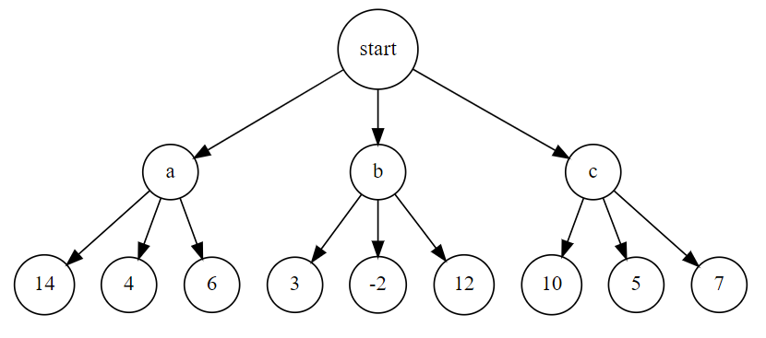  a) Apply the Minimax Algorithm to determine the optimal move for the Maximizer at the start node. Show all calculations for each node.  b) Apply Alpha-Beta Pruning to the same game tree and show how it reduces the number of node evaluations. Explain which nodes were pruned and why.  Solution:  a) Minimax Algorithm Solution:  In the Minimax algorithm, we evaluate the values bottom-up, assuming one player (Maximizer) tries to maximize the score, and the other player (Minimizer) tries to minimize it.  Step 1: Evaluate Leaf Nodes  At the bottom level, the terminal nodes have the values:  From node a: [14, 4, 6]  From node b: [3, -2, 12]  From node c: [10, 5, 7]  Step 2: Minimizer's Turn  At the second level, nodes a, b, and c are controlled by the Minimizer. Therefore, the Minimizer will choose the minimum value from each child set:  Node a: Min(14, 4, 6) = 4  Node b: Min(3, -2, 12) = -2  Node c: Min(10, 5, 7) = 5  Step 3: Maximizer's Turn  At the root node (Start), the Maximizer will now choose the maximum value among 4, -2, and 5:  Max(4, -2, 5) = 5  Minimax Conclusion:  The optimal outcome for the Maximizer is to choose Node c, with a value of 5.  b) Alpha-Beta Pruning Solution:  Alpha-Beta Pruning improves the efficiency of the Minimax algorithm by eliminating branches that won't affect the final decision.  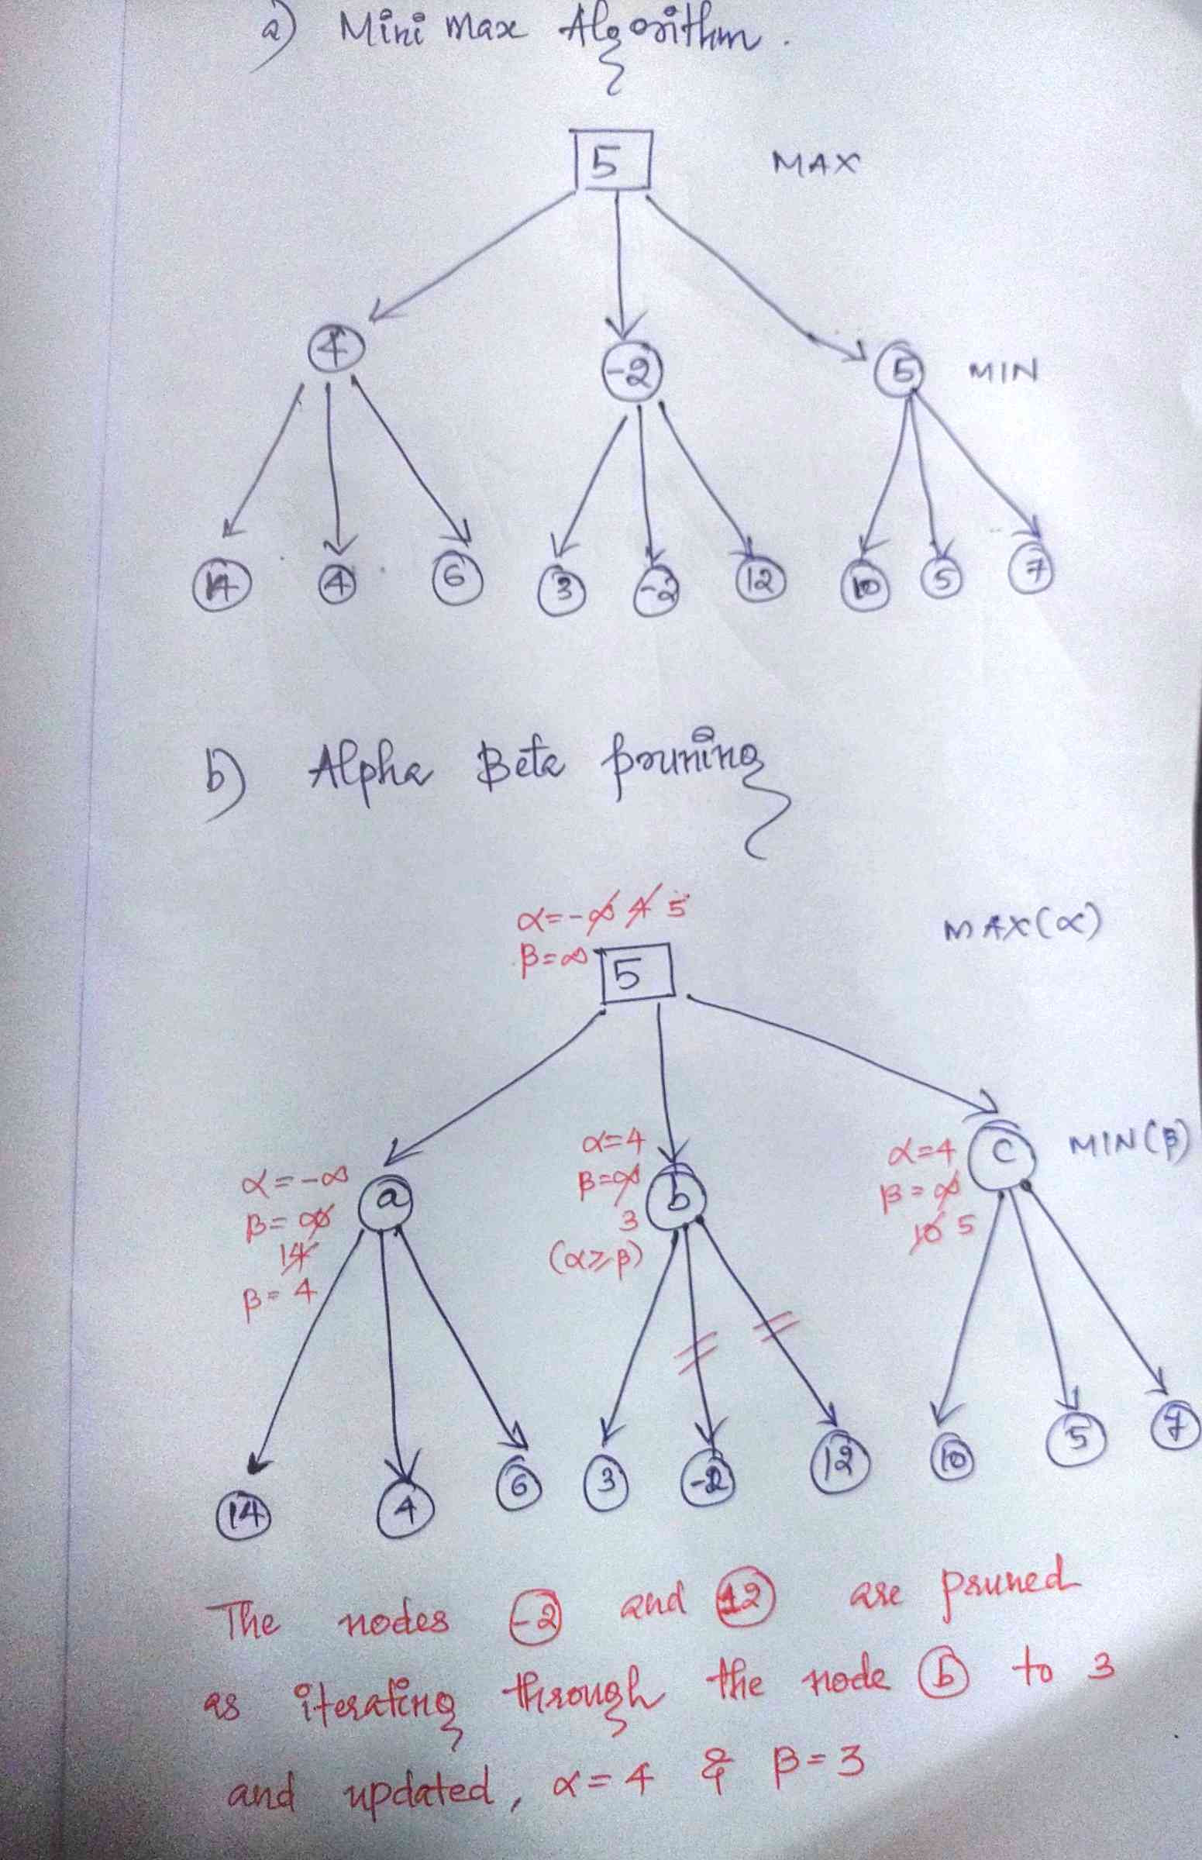 | 10 | CO4 | BL2
2. | Jake wants to be selected for a sports team. The selection criteria and Jake's circumstances are as follows:  - Anyone fast or strong gets selected.  - Training makes you fast.  - Exercise makes you strong.  - Jake trains but does not exercise.  Convert the given scenario into propositional logic statements and use resolution to prove that "Jake gets selected."  SOLUTION:  Step 1: Define Propositional Variables  We will represent the various aspects of the scenario using propositional variables:  F: Jake is fast.  S: Jake is strong.  T: Jake trains.  E: Jake exercises.  G: Jake gets selected.  Step 2: Convert Statements into Propositional Logic  The given scenario translates into the following logical expressions:  - Anyone fast or strong gets selected:  F∨S ⟹ GF \lor S \implies GF∨S⟹G  (If Jake is fast or strong, he gets selected.)  - Training makes you fast:  T ⟹ FT \implies FT⟹F  (If Jake trains, he is fast.)  - Exercise makes you strong:  E ⟹ SE \implies SE⟹S  (If Jake exercises, he is strong.)  - Jake trains but does not exercise:  T∧¬ET \land \neg ET∧¬E  (Jake trains, but he does not exercise.)  Step 3: Convert Implications into Clauses for Resolution  Next, we need to convert the implications into Conjunctive Normal Form (CNF), which is required for resolution.  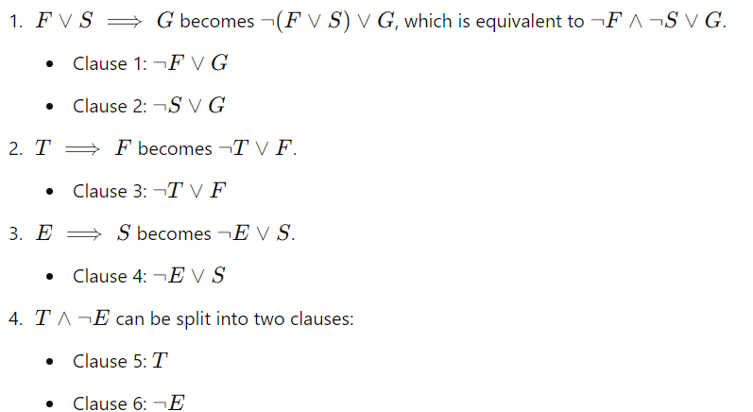  Step 4: Apply Resolution to Prove "Jake Gets Selected"  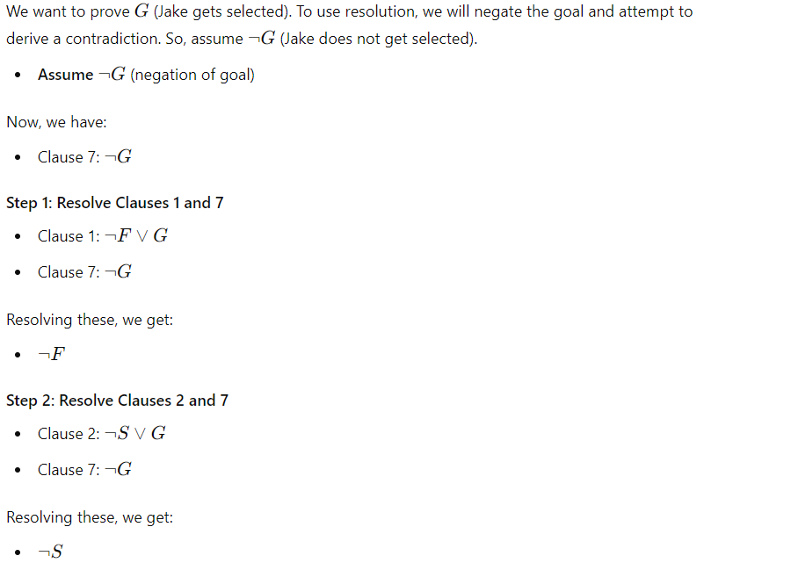  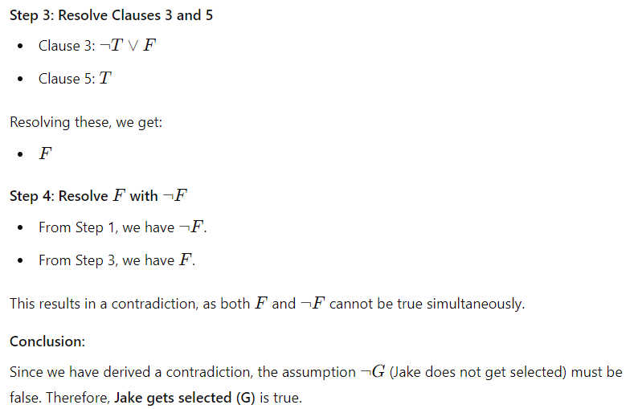 | 10 | CO2 | BL4
3. | Consider the following set of rules for classifying transportation modes:  Vehicles that have engines are motorized.  Vehicles that run on tracks and carry passengers are trains.  Vehicles that are motorized and have two wheels are motorcycles.  Vehicles that have wings and fly are airplanes.  Vehicles that are motorized, have four wheels, and carry passengers are cars.  The working memory contains the following assertions:  A1: Speedster has two wheels.  A2: Zoomer runs on tracks.  A3: Glider has wings.  A4: Speedster has an engine.  A5: Glider flies.  i) Use forward chaining to derive all assertions that are derivable from this knowledge base (i.e., from the set of rules together with the assertions in the working memory).  ii) Use backward chaining to determine whether Speedster is a motorcycle. Construct all trees showing the steps followed by forward and backward chaining, and show when and how the working memory is updated during the process.  Solution:  vehicle = x  R1: Speedster has an engine ?x has an engine  succeeds due to A4  WM := WM + {A6: Speedster is motorized} ?x is motorized  R2: Zoomer runs on tracks ?x runs on tracks  succeeds due to A2  Zoomer carries passengers ?x carries passengers  fails (no information about passengers)  hence Rule R2 is not triggered.  R3: Speedster has two wheels ?x has two wheels  succeeds due to A1  Speedster is motorized ?x is motorized  succeeds due to A6  WM := WM + {A7: Speedster is a motorcycle} ?x is a motorcycle  R4: Glider has wings ?x has wings  succeeds due to A3  Glider flies ?x flies  succeeds due to A5  WM := WM + {A8: Glider is an airplane} ?x is an airplane  b) Backward Chaining  Goal: Is Speedster a motorcycle?  Goal: Speedster is a motorcycle ?x is a motorcycle  R1: Vehicles that are motorized and have two wheels are motorcycles  |  ├── Condition 1: Is Speedster motorized?  | |  | └── Rule: Vehicles with engines are motorized ?x has an engine  | succeeds due to A4: Speedster has an engine  | hence, Speedster is motorized (Rule 1)  |  └── Condition 2: Does Speedster have two wheels? ?x has two wheels  succeeds due to A1: Speedster has two wheels  Conclusion: Speedster satisfies both conditions. Therefore, Speedster is a motorcycle. | 10 | CO2 | BL5
4. | Consider the following statements  - Any book in the library is more expensive than any magazine in the store.  - Any electric car is more efficient and produces less pollution than a gasoline car.  - There is exactly one student whose GPA is 4.0.  - There is a restaurant in Paris that serves better food than any other restaurant in the city.  - A person who helps others is respected by everyone.  a) Convert the following English statements into First-Order Logic (FOL)  b) Convert the above FOL expressions to Conjunctive Normal Form (CNF).  Solution: 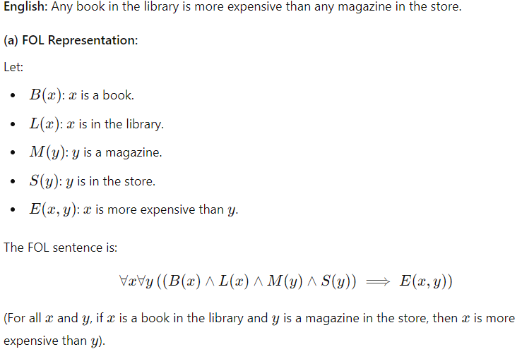  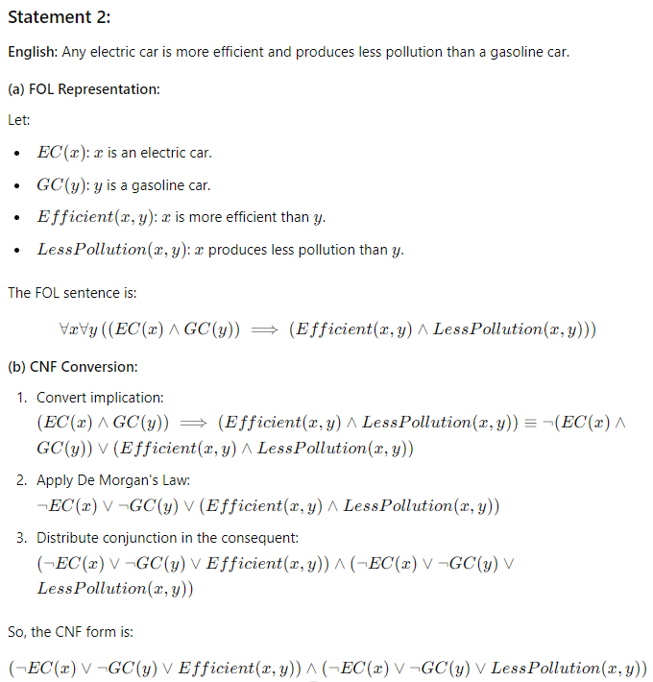  3.There is exactly one student whose GPA is 4.0.  CNF is  - There is a restaurant in Paris that serves better food than any other restaurant in the city.  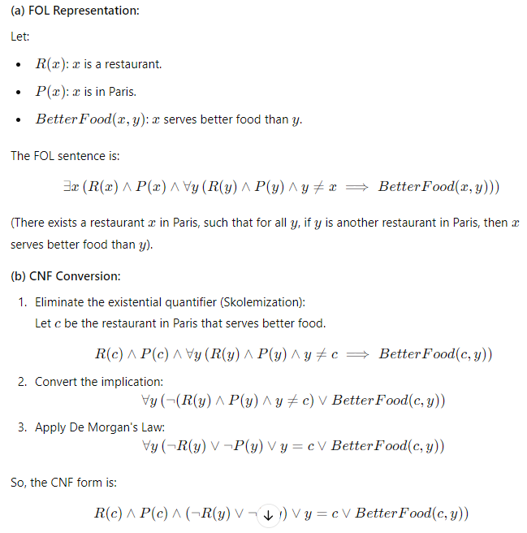 | 10 | CO2 | BL1
5. | Consider the following dataset that includes demographic information and symptoms for disease diagnosis:  a) Using the dataset provided, apply Naive Bayes Classification to predict the diagnosis of a new individual based on the following features:  Age Group: 30-40, Gender: Female, Fever: Yes, Cough: Yes, Fatigue: Yes, Sore Throat: No  Age Group Gender Fever Cough Fatigue Sore Throat Diagnosis  <30 Female Yes Yes Yes No Flu  30-40 Male Yes Yes No Yes COVID-19  >40 Female No Yes Yes Yes Allergies  <30 Male Yes No Yes No Flu  30-40 Female Yes Yes Yes Yes COVID-19  >40 Male No No No No Healthy  <30 Female Yes Yes No Yes COVID-19  30-40 Male Yes No Yes Yes Flu  >40 Female Yes Yes Yes Yes COVID-19  30-40 Male No Yes No No Allergies  b) Based on the data given, answer the following:  i)What is the probability that an individual has a COVID-19 diagnosis given that they are Male and have Fatigue and Cough?  ii) Given that an individual has No Fever and No Cough, what is the probability that their diagnosis is Healthy?  Solution a  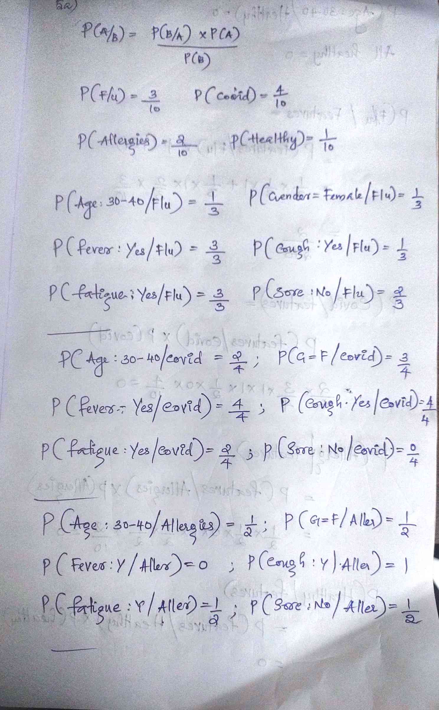  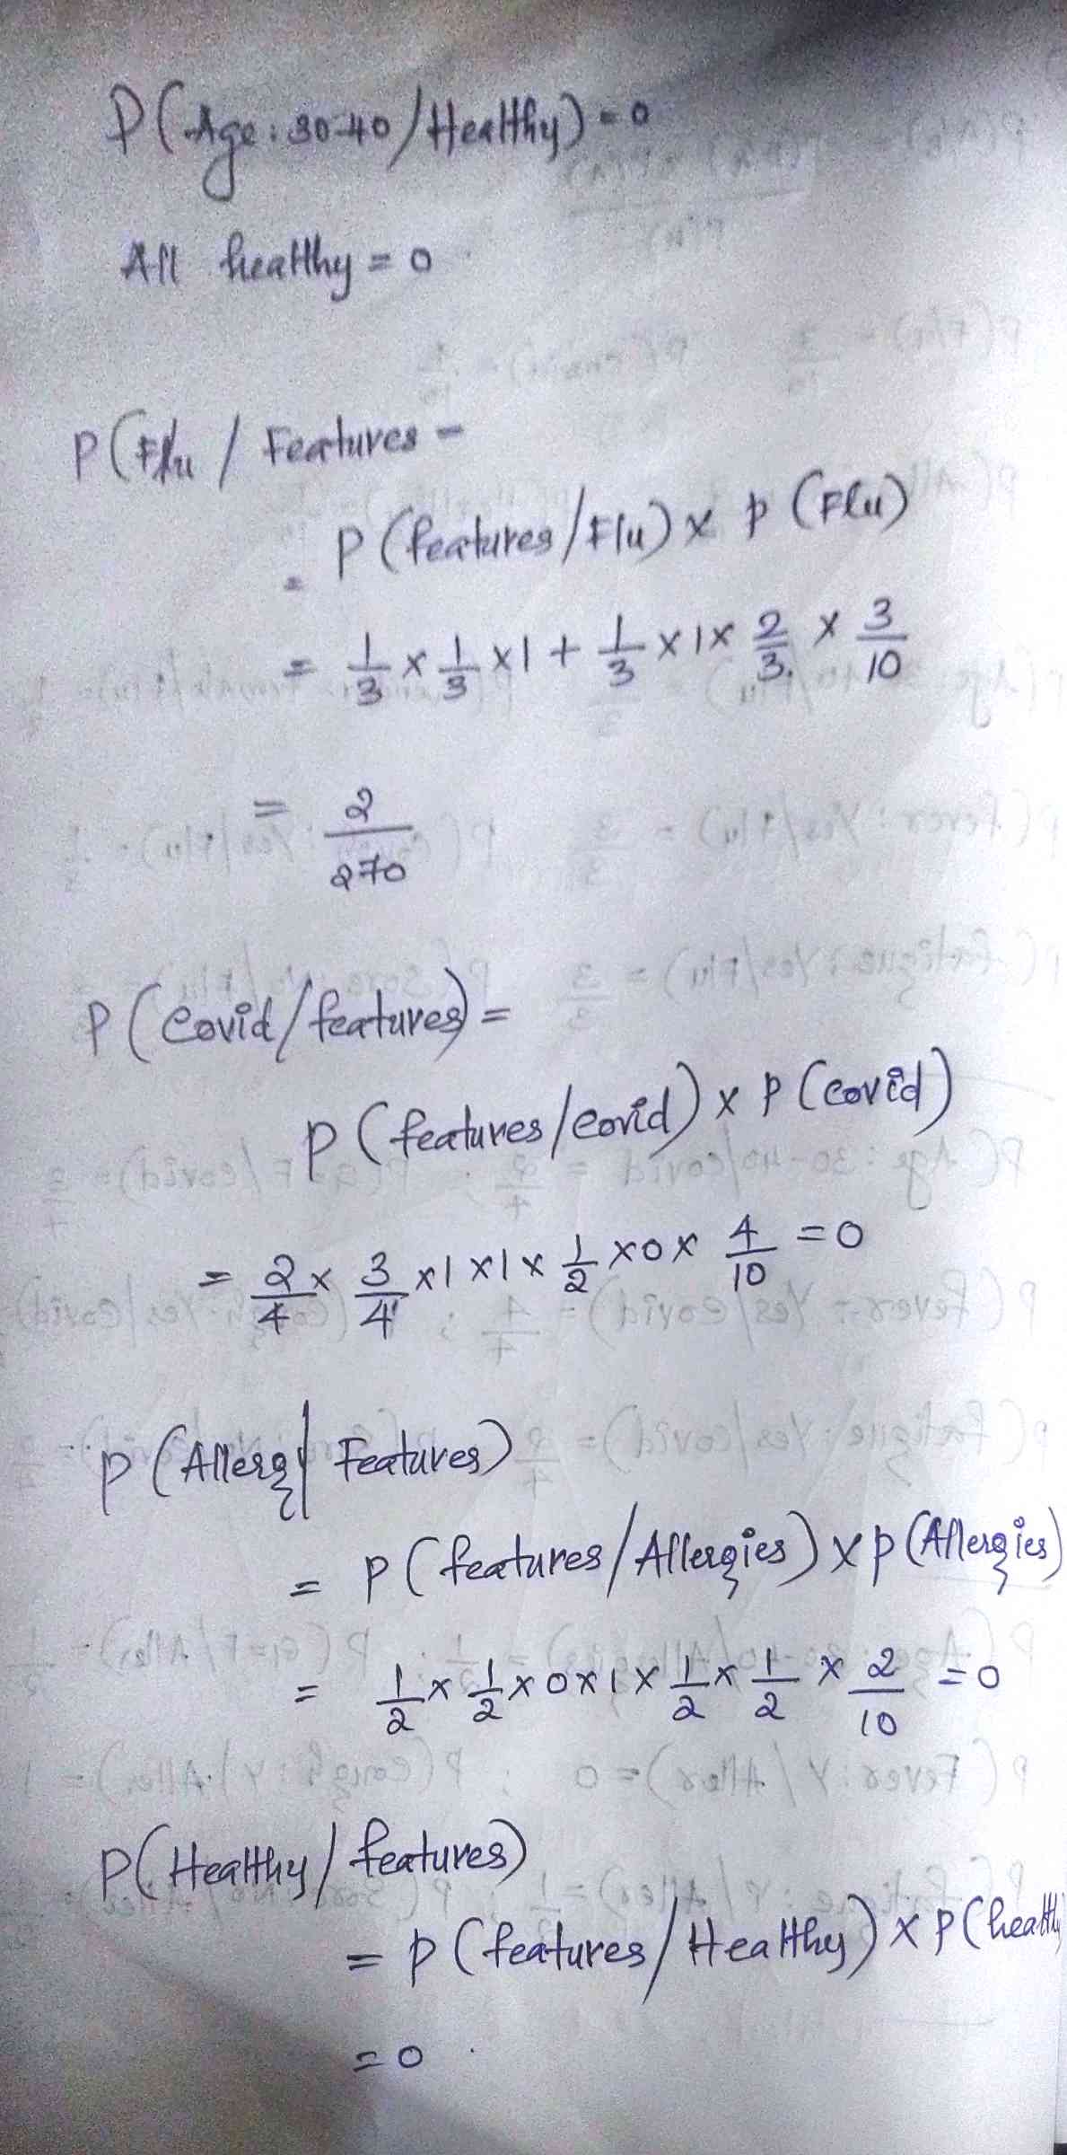  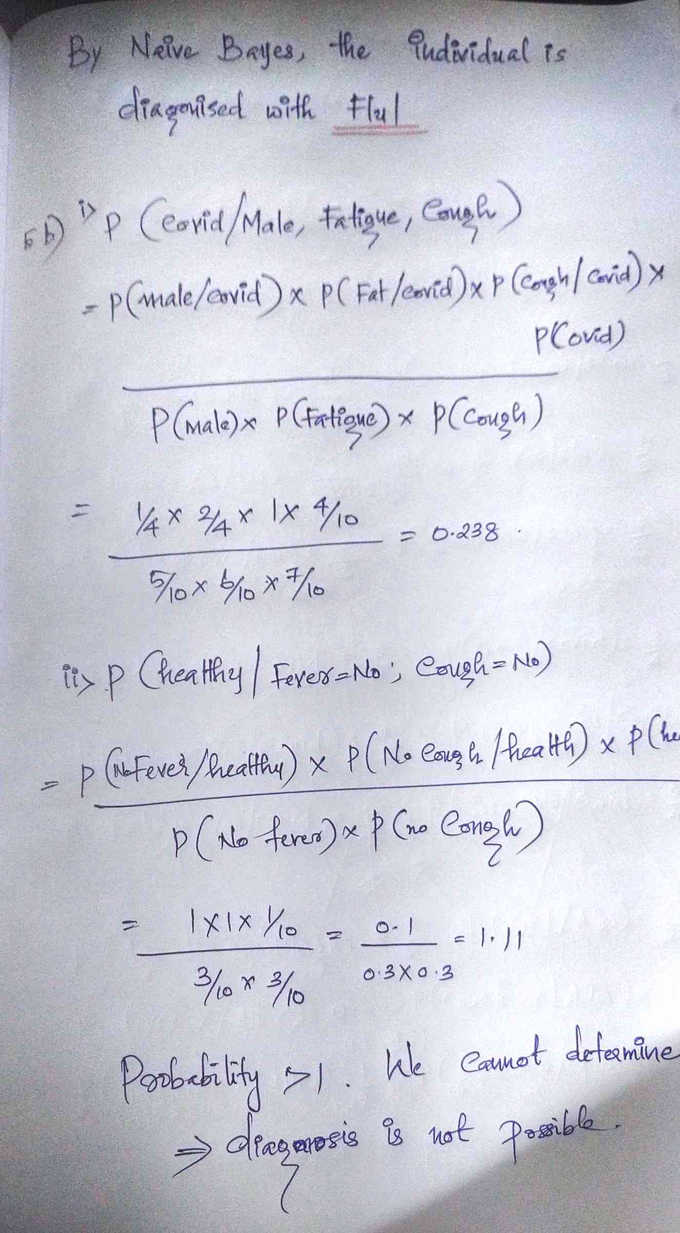 | 10 | CO3 | BL3

